**NAMA : JAMALUDIN**

**TYPE : EASY**

**TUGAS FROM**[***https://www.hackerrank.com/domains/java***](https://www.hackerrank.com/domains/java)

1. **Question “Wellcome to java”**

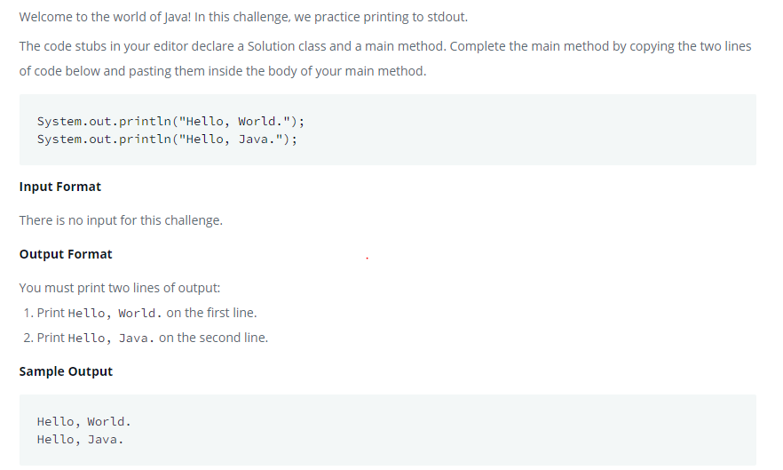

**Answer**

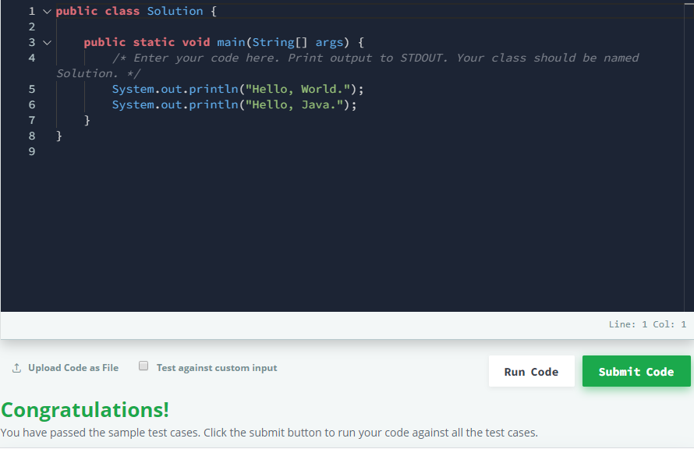

1. **Question “Java Stdin AND Stdout 1**

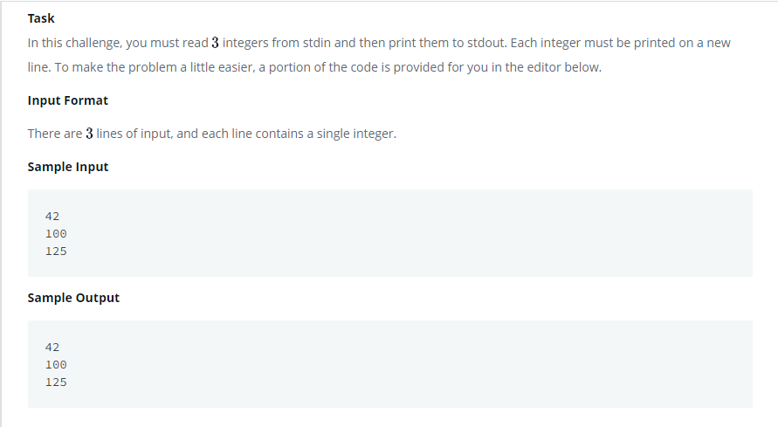

**Answer**

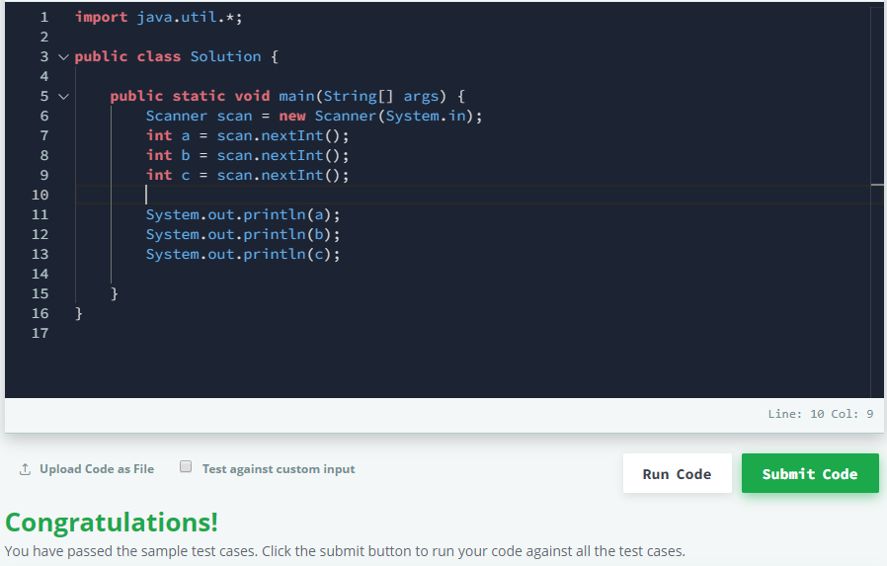

1. **Qeustion “Java Int to String”**

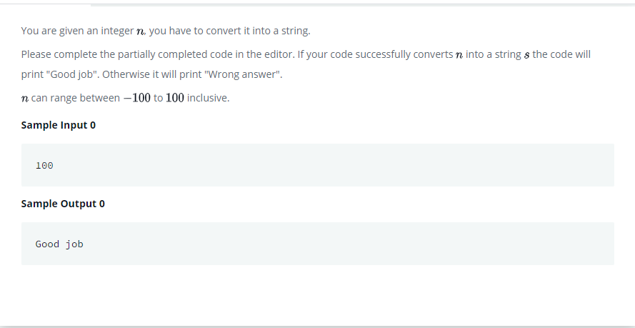

**Answer**

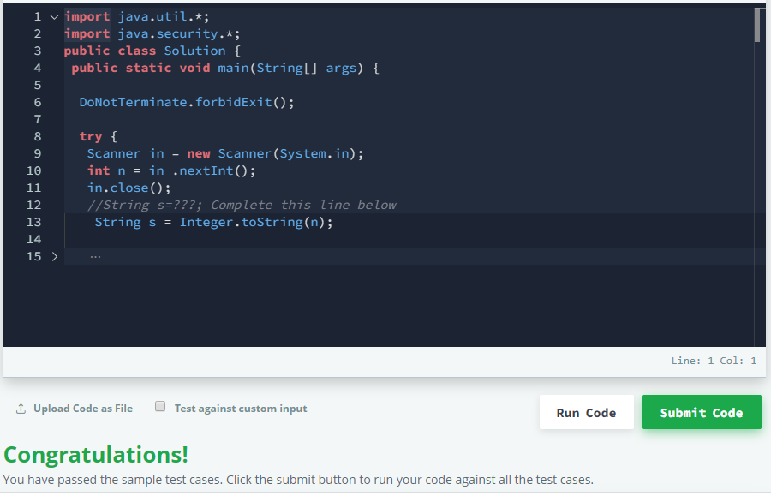

1. **Question “Java Inheritance 1”**

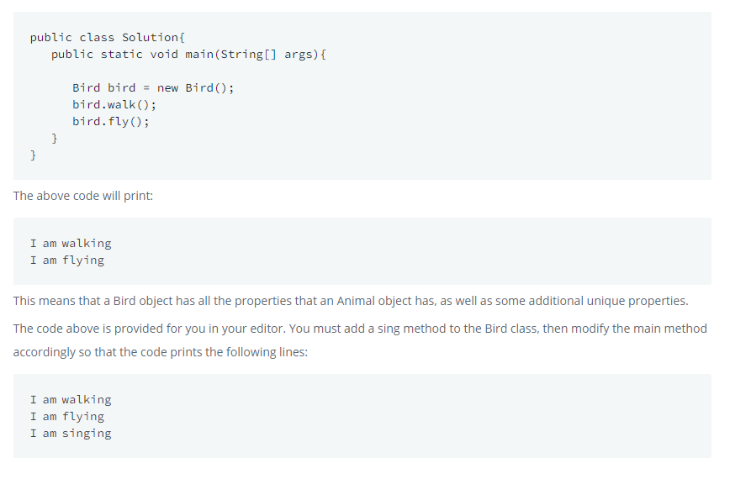

**Answer**

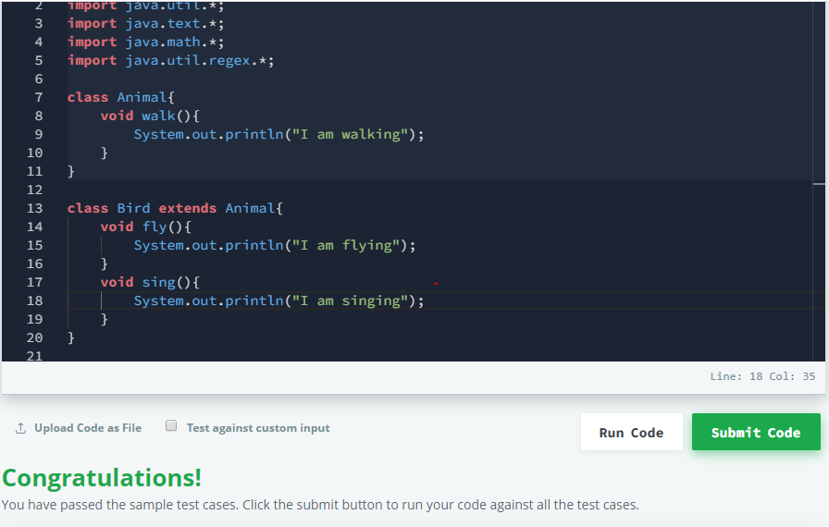

1. **Question “Java Stdin Stdout 2”**

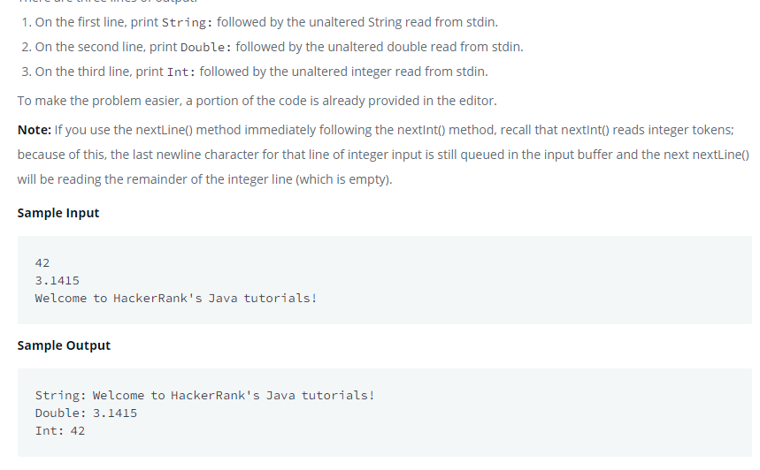

**Answer**

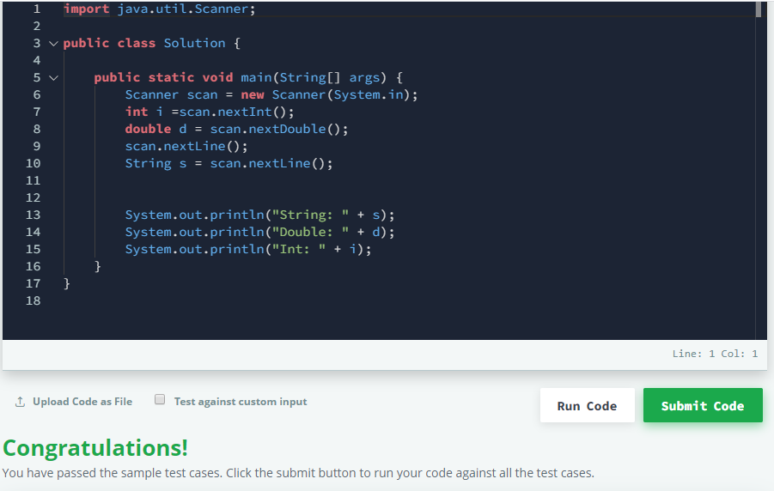

1. **Question “Java Output Formatting**

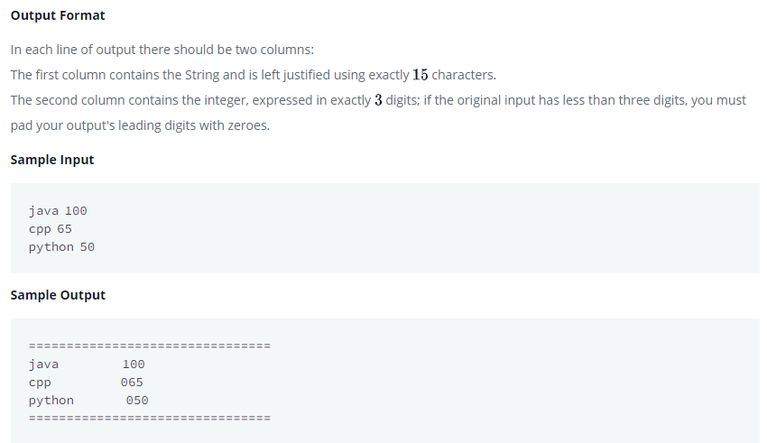

**Answer**

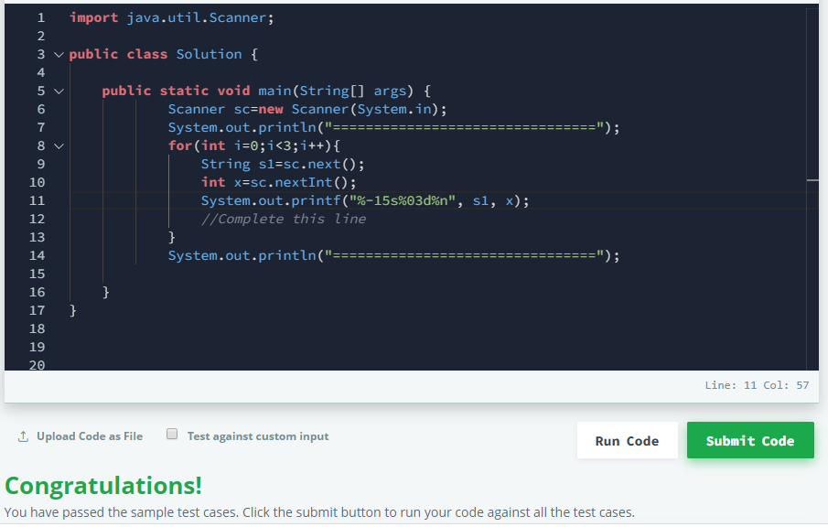

1. **Question Java Loops 1**

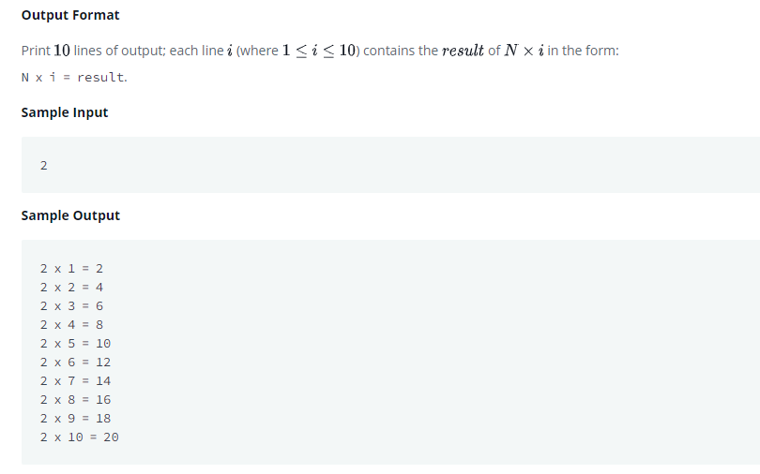

**Answer**

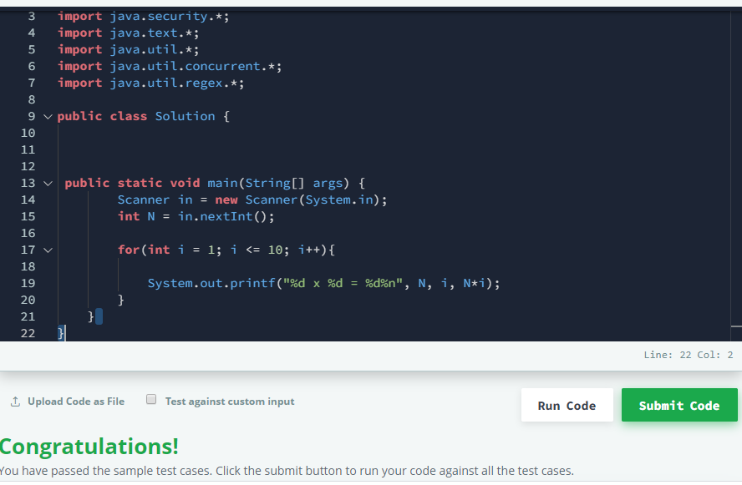

1. **Question Java String Introduction**

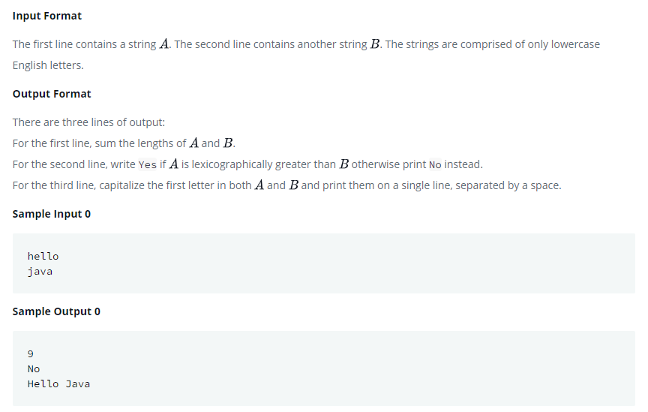

**Answer**

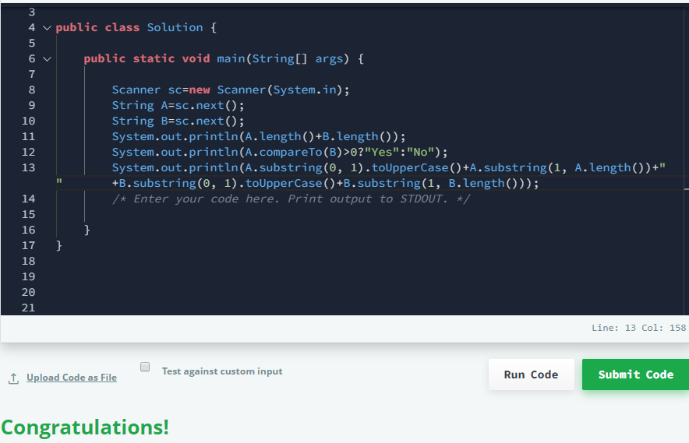

**NAMA : JAMALUDIN**

**TYPE : MEDIUM**

<https://www.hackerrank.com/domains/java>

1. **Question “Can you acces?”**

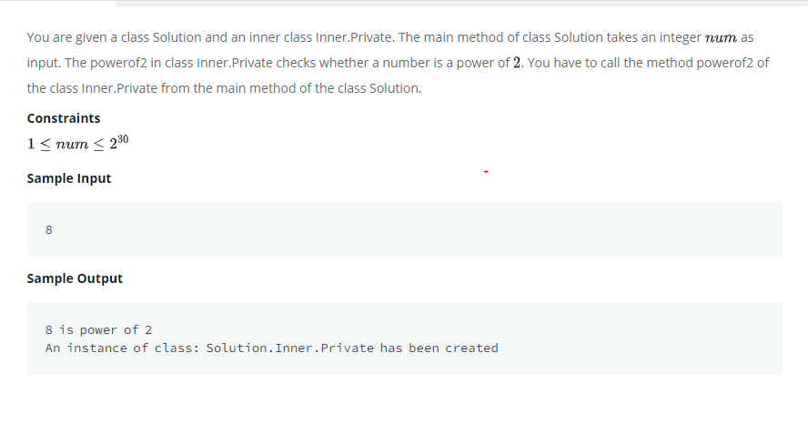

**Answer**

